Assignment_1 NLP

Q.1 Explain the different phases of NLP with a neat diagram.
Natural Language Processing (NLP) is a field of Artificial Intelligence that enables computers to understand, interpret, and generate human language. NLP works in multiple phases to convert raw text into meaningful information.
Phases of NLP
1. Lexical Analysis
- First phase of NLP.
- Converts input text into tokens (words, numbers, punctuation).
- Removes unnecessary symbols.
- Identifies base word forms.
2. Syntax Analysis (Parsing)
- Checks grammatical structure of the sentence.
- Determines subject, verb, object relationships.
- Uses grammar rules.
- Builds parse tree.
3. Semantic Analysis
- Determines the meaning of words and sentences.
- Resolves ambiguity.
- Assigns correct meaning based on context.
- Creates semantic representation.
4. Discourse Integration
- Connects meaning across multiple sentences.
- Maintains context.
- Resolves pronouns (he, she, it).
- Ensures logical flow.
5. Pragmatic Analysis
- Understands intended meaning.
- Uses real-world knowledge.
- Considers speaker intention.
- Interprets implied meanings.

Neat Diagram of NLP Phases
Input Text
↓
Lexical Analysis
↓
Syntax Analysis
↓
Semantic Analysis
↓
Discourse Integration
↓
Pragmatic Analysis
↓
Final Meaning / Output

Q.2 Describe the process of Lexical Analysis in NLP. What are tokenization and stemming?
Lexical Analysis is the first step in NLP where raw text is converted into meaningful units.
Process of Lexical Analysis
- Input sentence is received.
- Sentence is divided into tokens.
- Punctuation marks are removed.
- Stop words may be removed.
- Words are converted to lowercase.
- Root forms of words are identified.
- Tokens are prepared for further analysis.

Tokenization
Tokenization is the process of breaking text into smaller units called tokens.
Example:
Sentence:
NLP is very interesting.
After Tokenization:
["NLP", "is", "very", "interesting"]
Types:
- Word Tokenization
- Sentence Tokenization

Stemming
Stemming reduces a word to its root form by removing suffixes.
Example:
Word | Stem
Playing | Play
Running | Run
Studies | Studi
Stemming is simple and fast but may not always give correct root word.

Q.3 Demonstrate how Named Entity Recognition (NER) can be used to extract entities from a paragraph.
Named Entity Recognition (NER) is an NLP technique used to identify and classify important entities in text such as:
- Person
- Organization
- Location
- Date
- Time
- Money
- Percentage

Example Paragraph
"Narayan Behera is studying at Amity University Mumbai. He lives in Mumbai and will join TCS in July 2026."

Entities Extracted using NER
Entity Type | Extracted Entity
Person | Narayan Behera
Organization | Amity University Mumbai
Location | Mumbai
Organization | TCS
Date | July 2026

NER Working Diagram
Input Paragraph
↓
Tokenization
↓
Model Processing
↓
Entity Classification
↓
Structured Output (Person, Location, Org, Date)
NER is widely used in:
- Chatbots
- Resume screening
- News analysis
- Search engines

Q.4 Analyze the differences between Syntax Analysis and Semantic Analysis in NLP.
Syntax Analysis and Semantic Analysis are two important phases of NLP but they focus on different aspects.
Syntax Analysis (Parsing)
- Checks grammatical correctness.
- Focuses on structure.
- Builds parse tree.
- Uses grammar rules.
- Example: "She go to school" → Incorrect grammar.
Semantic Analysis
- Focuses on meaning.
- Interprets word sense.
- Resolves ambiguity.
- Checks logical correctness.
- Example: "Colorless green ideas sleep furiously" → Grammatically correct but meaningless.

Comparison Table
Syntax Analysis | Semantic Analysis
Structure based | Meaning based
Grammar rules used | Context and knowledge used
Creates parse tree | Creates meaning representation
Detects grammatical errors | Detects meaning errors
Earlier phase | After syntax analysis

Diagram
Sentence
↓
Syntax Analysis → Checks grammar
↓
Semantic Analysis → Checks meaning

Q.5 Examine the role of Discourse Analysis in understanding multi-sentence text.
Discourse Analysis studies how multiple sentences connect and form meaningful communication.
It ensures text coherence and context understanding.

Role of Discourse Analysis
1. Resolving Pronouns
Example:
"Ravi bought a car. He loves it."
- He → Ravi
- it → Car
2. Maintaining Context
Understands topic continuity.
3. Logical Flow
Ensures ideas are connected.
4. Identifying Relationships
Cause-effect, contrast, sequence.
5. Removing Ambiguity
Clarifies references across sentences.

Example
Text:
"Anita went to the market. She bought apples. They were fresh."
Discourse Analysis identifies:
- She → Anita
- They → Apples

Diagram of Discourse Analysis
Sentence 1 → Meaning 1
Sentence 2 → Meaning 2
Sentence 3 → Meaning 3
↓
Discourse Integration
↓
Contextual Understanding

✅ Conclusion
Natural Language Processing consists of multiple phases:
- Lexical
- Syntax
- Semantic
- Discourse
- Pragmatic
Each phase plays an important role in converting human language into structured, meaningful information that machines can understand.
Here are expanded 5-mark answers (more lines + diagram) — still short, exam-ready.

Q.1 Explain the concept of Regular Expressions. Also explain basic operators (union, concatenation, Kleene star) and illustrate with examples how they generate regular languages.
Definition
- Regular Expression (RE) is a formal notation used to represent a set of strings.
- It defines regular languages accepted by finite automata.
- Used in pattern matching, compilers, and text processing.
- Built using symbols and operators.
Basic Operators
- Union ( | )
  - Represents choice between symbols.
  - Example: a|b → {a, b}
- Concatenation
  - Combines two expressions.
  - Example: ab → {ab}
- Kleene Star ( * )
  - Repeats expression 0 or more times.
  - Example: a* → {ε, a, aa, aaa…}
Example
- (a|b)* → all possible strings over {a,b}
- a*b → strings ending with b
Key Points
- RE is equivalent to finite automata
- Used to generate and recognize patterns
- All RE form regular languages

Diagram

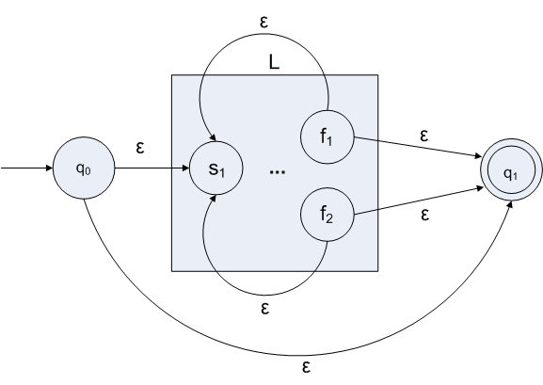

Q.2 Derive a Regular Expression for a given finite automaton.
Explain the step-by-step process of converting a DFA/NFA into an equivalent regular expression with a suitable example.
Concept
- DFA/NFA and Regular Expressions are equivalent.
- Every automaton can be converted into RE.
Steps (State Elimination)
- Draw DFA/NFA clearly
- Add new start and final states (if needed)
- Remove intermediate states
- Update transitions using formula
- Continue until only start & final remain
- Final label = Regular Expression
Formula Used
- R = R1(R2)*R3 | R4
Example
- Language: Strings ending with a
- RE: (a|b)*a
Key Points
- State elimination simplifies automaton
- Combines paths using union and star
- Final RE represents same language

Diagram

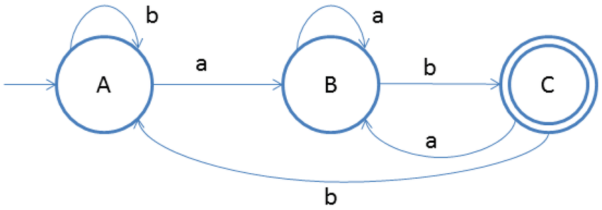

Q.3 Construct a Regular Expression for the language
$L=\{w∈\{a,b\}^{*}∣w\text{ ends with }abb\}$.
Also, design a finite automaton for the same and verify correctness.
Regular Expression
- (a|b)*abb
Explanation
- (a|b)* → any string
- abb → fixed ending
- Ensures last three characters are “abb”
DFA States
- q0 → start
- q1 → ‘a’ matched
- q2 → ‘ab’ matched
- q3 → ‘abb’ matched (final)
Transition Logic
- Moves step-by-step matching suffix
- Resets if pattern breaks

DFA Diagram
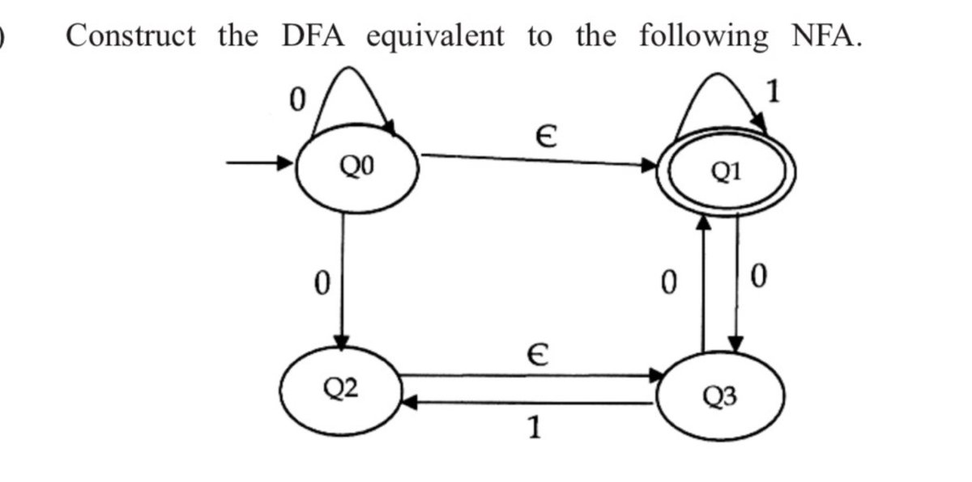

Verification
- abb → Accepted
- aabb → Accepted
- babb → Accepted
- aba → Rejected
- abbb → Rejected
Key Points
- Final state ensures correct suffix
- DFA checks last 3 characters
- Matches RE exactly

Q.4 Explain the role of Regular Expressions in NLP.
Discuss how they are used in text preprocessing tasks such as tokenization, normalization, and pattern matching with examples.
Concept
- Regular Expressions are used in NLP for text preprocessing and pattern extraction.
- Helps clean and prepare text data before analysis.
Uses
- Tokenization
  - Splits text into words/sentences
  - Example: [A-Za-z]+
- Normalization
  - Removes extra spaces, punctuation
  - Converts text into standard form
- Pattern Matching
  - Finds emails, numbers, dates
  - Example: \w+@\w+\.\w+
- Data Cleaning
  - Removes unwanted characters
  - Filters noise
- Information Extraction
  - Extracts useful data from text
Examples
- "Hello!!!" → "Hello"
- "This is NLP" → "This is NLP"
Key Points
- Improves data quality
- Used before ML models
- Fast and efficient

Diagram
